**DECLARATION of ERASMUS Policy of the National Defence Academy of Latvia**

**The National Defence Academy of Latvia (NDAL) is a state higher** **education and science institution of the Republic of Latvia, which was restored on 13 February 1992 and is** **the inheritor of the traditions of the Latvian War School founded in 1919. The basic principles of the operation of the NDAL are the preparation of the** **staff of professionally educated commanding and military specialists for the protection of the Latvian state; organization and conducting of research** **in the field of national defence and security, raising of new military intelligence, officers – patriots of Latvia, mentally and physically developed personalities with high morality, a sense of honour and duty, leaders who** **are able to take responsibility and successfully manage their subordinates.**

**In 2015, the Cabinet of Ministers issued an order on the approval of the Constitution of the National Academy of Defence (NDAL), where among the most important core directions of activities of the NDAL** **and its tasks, there is international cooperation and its development for the** **exchange of personnel and students with other institutions of higher education and foreign military training institutions that prepare officers.** **The need to develop and strengthen international co-operation is also highlighted in the 2016 Saeima Communication “on Confirmation of the State Defence Concept”, where in Sub-paragraph 3.2.4 “Participation in International Security Policy” it is reaffirmed that comprehensive international co-operation is an additional instrument for defending the defence interests of the State. In order to comply with the provisions of the documents listed above, it was decided to engage in ERASMUS + and to take advantage of the opportunities offered by the programme.**

**At the end of 2016, the NDAL prepared an application and received a standard ERASMUS University** **Charter 2014-2020 (Charter), a written document issued by the European Commission, empowering a higher** **education institution to participate in ERASMUS + programme activities. Upon the receipt of the Charter, the NDAL undertakes to** **comply with the fundamental principles set out in the Charter, to which higher education institutions must adhere when organizing and implementing ERASMUS + programme activities.**

**ERASMUS University Charter is a prerequisite for a higher education institution to** **apply for funding:**

* **organising mobility of students, academic and other staff abroad;**
* **admission of docents, lecturers and staff of foreign higher education institutions to their higher** **education institution;**
* **ERASMUS for intensive language courses and intensive programmes;**
* **coordination of multilateral projects, networks of international higher education institutions, accompanying activities;**
* **preparation for arranging trips.**

**Already in spring 2018, the NDAL submitted its first project application for the implementation of European Union Programme on Erasmus + learning Mobility and received a positive decision on the provision of funding, resulting in the successful implementation of the first ERASMUS + project by the NDAL from 1 June 2018 to 30 September 2019 through 11 staff development and doctoral mobility.**

**As early as spring 2019, a further project application was submitted, which was also approved** **and the NDAL gained an opportunity to implement the second ERASMS +** **project from June 1, 2019 to September 30, 2020. As a part of the project, 26 mobilities were implemented, four of which were study mobility. It was the** **implementation of study mobility that became a major milestone for the project, which, given the** **specificity of the NDAL as a military higher education institution, is a major step towards achieving the strategic objectives of the NDAL :to enable prospective officers to acquire experience at least once during their studies in military higher education institutions of other countries, which not only provides an opportunity to acquire knowledge and skills from the perspective of other countries, but also extends the vision and involvement of cadets in the military sphere in an international environment, which will be an indispensable benefit in their further careers.**

**In spring 2020, the NDAL submitted a project application for the Erasmus + programme for the third time, as a part of which, in view of the rapid growth of the Erasmus programme *European Initiative for Exchange of young officers inspired by ERASMUS* - *EMILYO)* in the development and provision of military mobility, where the NDAL is also actively involved, it is planned to realise mobility of at least 6 students, as well as to increase the mobilisation of doctoral and staff development.**

**So far, as part of the two projects, the NDAL has concluded eight ERASMUS + cooperation agreements with other higher education institutions:**

* **National Defence Academy of Georgia (Gea);**
* **Helmut Schmidt University (DE);**
* **Theresian Military Academy (AT);**
* **The General Jonas Žemaitis Military Academy of Lithuania (LT);**
* **Royal Military Academy (BE);**
* **University of Pisa (IT);**
* **Nicolae Balcescu Land Forces Academy (RO);**
* **Estonian Military Academy (EE);**
* **University of Defence (CZ);**
* **University of Pisa (IT);**
* **Portuguese Military Academy (PT).**

**Apart from the partner universities already listed, the NDAL is cooperating with more than 15 military higher education institutions, with which it is planned to enter into inter-institutional agreements as a part of future projects.**

**The NDAL will also continue its work in the future as a part of the Charter to promote the growth of international cooperation, as well as to actively engage in EMILYO to offer NDAL cadets and staff more and more opportunities to go on mobilities, as well as to get involved in the training process at the NDAL, thereby ensuring the development and improvement of competencies of both emerging officers and personnel.**

NDAL Rector

Colonel

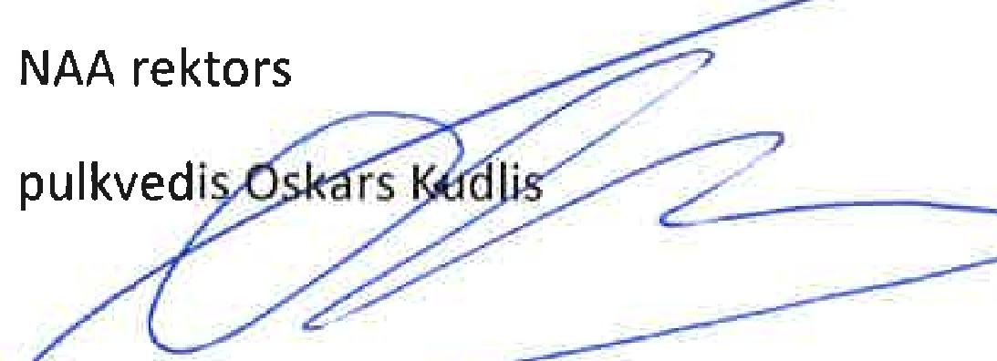

**More information on the programme can be found on the website of the State Education Development Agency, Section “Erasmus+”** [**www.viaa.gov.lv**](http://www.viaa.gov.lv)

Contact person on the implementation of the ERASMUS + project at the NDAL : **Zane Ribakova**

NDAL International Relations Coordinator

email: [zane.ribakova@nnil.lv](mailto:zane.ribakova@nnil.lv)